**Database Assignment # 3 – Linking tables**

Use the Database Assignment #3 worksheet that you download from our course to answer the following questions. When completed, you will upload the file in MyPHSC.

1. For the three tables, identify the Primary Keys and composite primary keys.

**Entertainer_Styles**

EntertainerID

StyleID

StyleStrength

**Styles**

StyleID

StyleName

**Entertainers**

EntertainerID

EntStageName

EntSSN

EntStreetAddress

EntCity

EntState

EntZipCode

EntPhoneNumber

EntEmailAddress

DateEntered

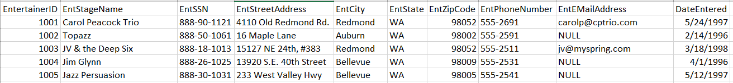

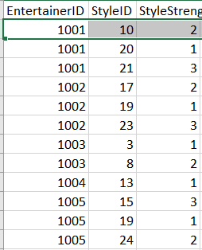 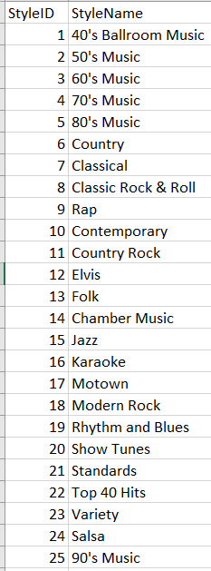

2. For the three tables, identify the Primary Keys and composite primary keys.

**Classes**

ClassID

ClassName

SubjectID

ClassRoomID

SemesterNumber

**Faculty_Classes**

StaffId

ClassID

**Faculty**

StaffID

Title

FirstName

LastName

Status

Tentured

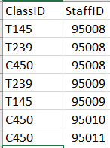

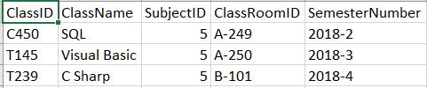

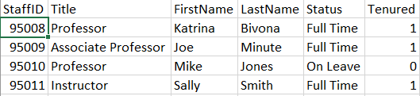3. Put into words the relationship of the tables from question # 2.

4. For the three tables, identify the Primary Keys and composite primary keys.

**Classes**

ClassID

ClassName

SubjectID

ClassRoomID

SemesterNumber

**Students**

StudentID

FirstName

LastName

Address

City

State

PhoneNumber

Email

**Student_Schedules**

ClassID

StudentID

ClassStatus

Grade

5. Put into words the relationship of the tables from question # 4.

6. For the three tables, identify the Primary Keys and composite primary keys.

**Products**

ProductNumber

ProductName

RetailPrice

QtyOnHand

CategoryID

**Vendors**

VendorID

VendName

VendAddress

VendCity

VendState

VendZip

VendPhoneNumber

VendEmail

**Product_Vendor**

ProductNumber

VendorID

WholesalePrice

DaystoDeliver

7. Put into words the relationship of the tables from question # 6.

8. This is **NOT** a Linking Table but it still uses a Composite Primary Key. For the two tables, identify the Primary Keys and Composite primary keys.

**Order_Details**

OrderNumber

LineNumber

QuotedPrice

QuantityOrdered

**Orders**

OrderNumber

OrderDate

ShipDate

CustomerID

EmployeeID

OrderTotal

9. For the three tables, identify the Foreign Keys, Primary Keys and Composite primary keys.

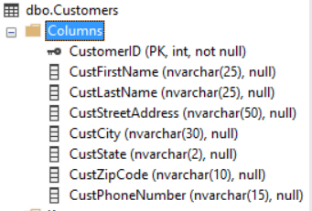

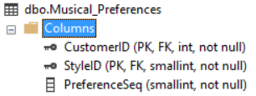

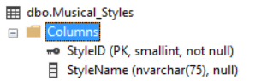

10. For the three tables, identify the Foreign Keys, Primary Keys and Composite primary keys.

